**A**

**Micro Projected On**

**“ Faraday’s Law of electromagnetic induction.”**

In

**Name Of the Course :Elements Of Electrical Engineering**

**By**

**Name of the students (Roll No ):**

**Rushi Raviraj Gujarathi(533)**

|  |  |  |
| --- | --- | --- |
|  |  |  |
|  | Ghorpade Tanvi Krishna | 531 |
|  | Giri Shubham Dinesh | 532 |
|  | Gujarathi Rushi Raviraj | 533 |
| **4** | Gunjal Mansi Pravin | 534 |
| **5** | Iyer Vishal Jaikanth | 535 |

**Mrs. Deshpande Anupama Wankhade.**

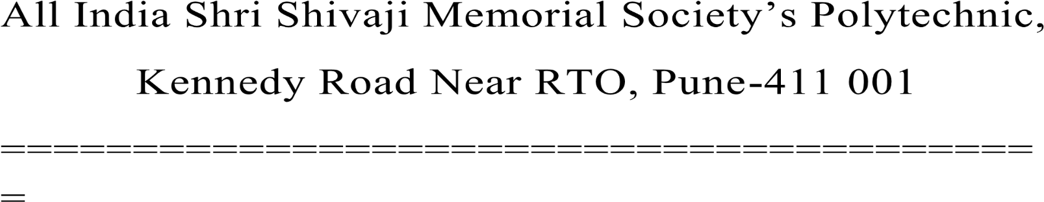**Certificate**

Certified that this Microproject report titled – “**Faraday’s Law of electromagnetic induction** “is the bonafide work of **Ms/Mr. Ghorpade Tanvi, Giri Shubham, Gujarathi Rushi, Gunjal Mansi, Iyer Vishal** Roll no **531,532,533,534,535** of first year diploma in **Computer Engineering**.

Engineering of the Course: **Elements Of Electrical Engineering**  Course code :**22215** during the academic year 2022-2023, Who carried out the micro project work under my supervision.

Name and Signature Subject Teacher

Mrs.**Deshpande Anupama Wankhade.**

|  |  |  |
| --- | --- | --- |
|  |  |  |
|  |  | 1 |
|  |  | 1 |
|  |  | 1 |
|  |  | 2 |
|  |  | 3 |
|  |  | 4 |
|  |  | 5 |
|  |  | 5 |
|  |  | 6 |
|  |  | 7 |
|  |  | 8 |
|  |  | 10 |
|  |  | 10 |